Homework 4
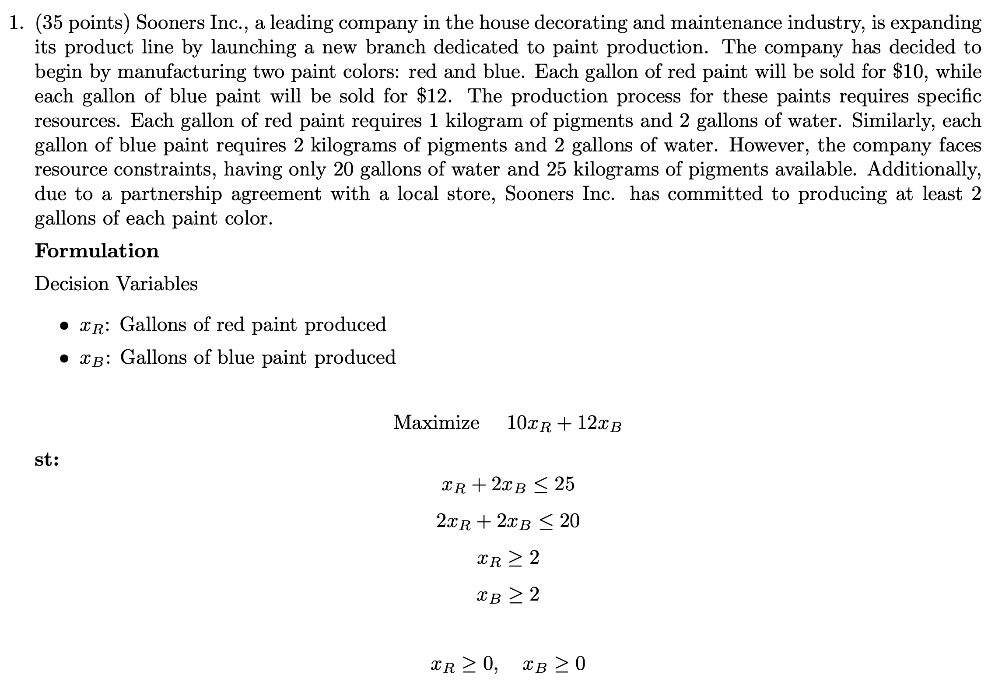

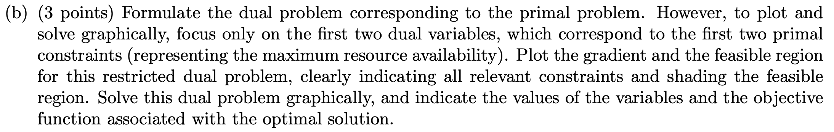

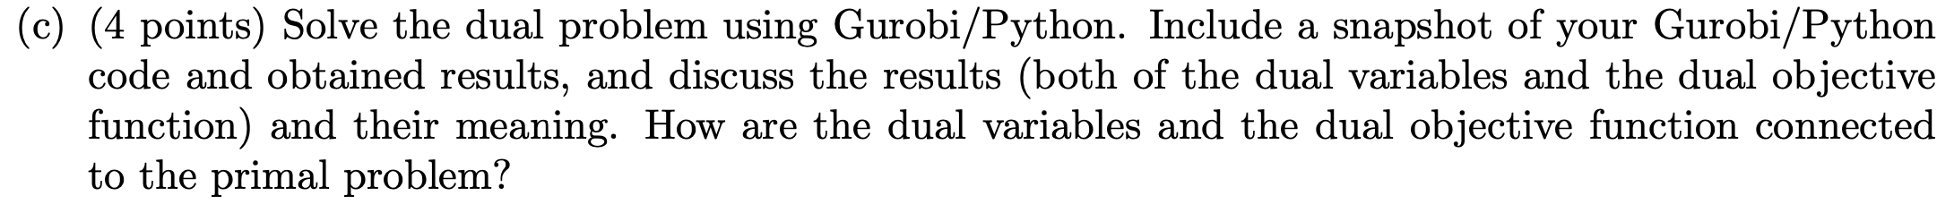
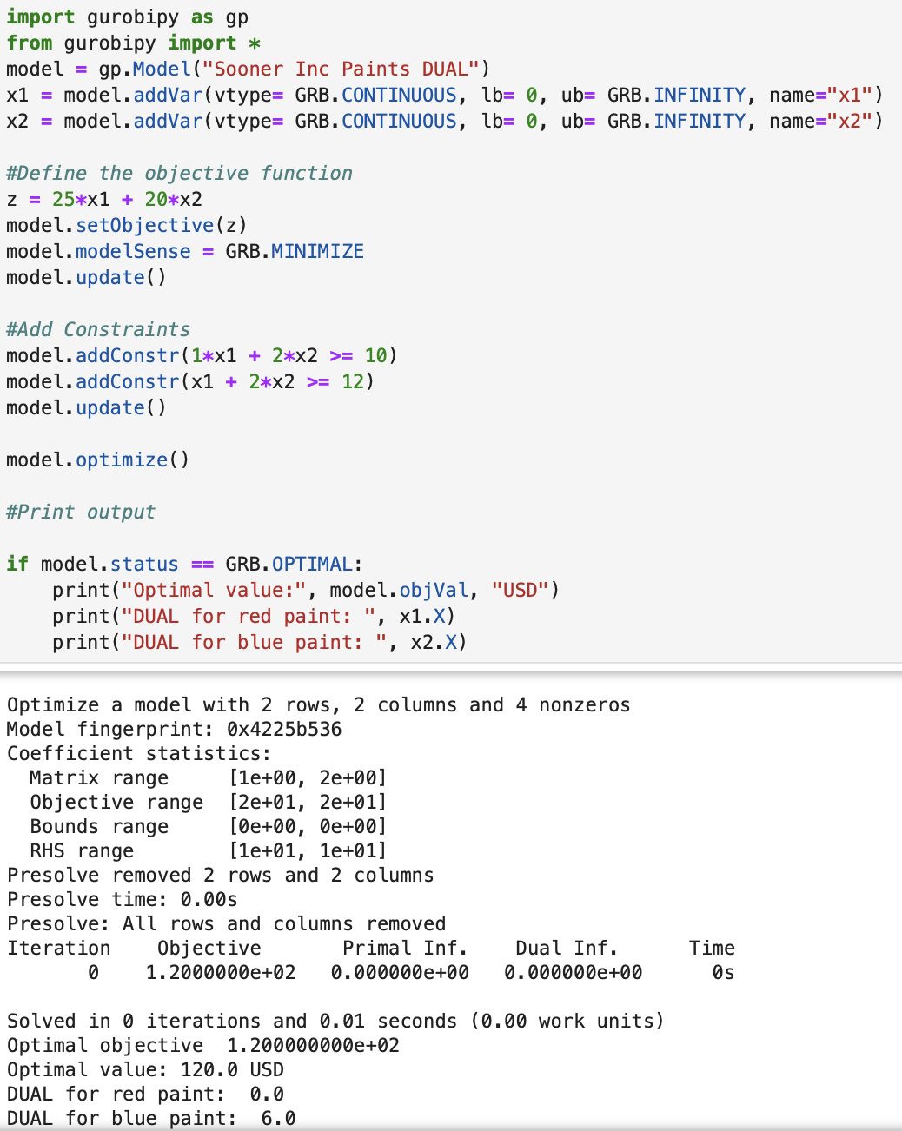

Dual Objective: The dual objective function value (120 USD) provides insight into the total cost in the dual world, which relates to the pricing of constraints from the primal problem.
Dual Variables: These represent the marginal values of increasing the resources in the primal. If a dual variable is zero, it means the associated constraint is not binding in the primal problem (additional resources would not improve the objective value).

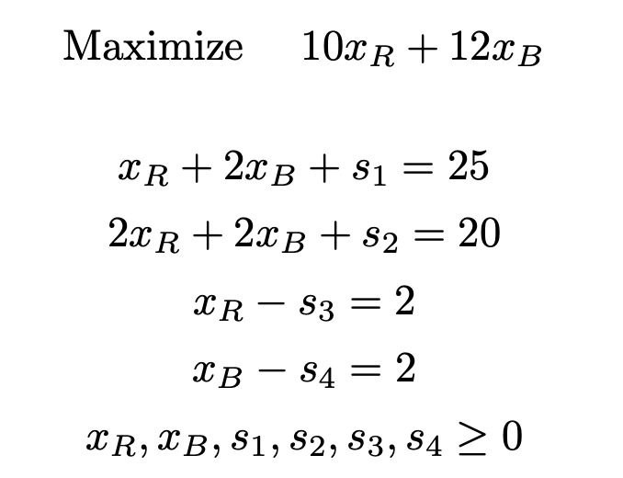

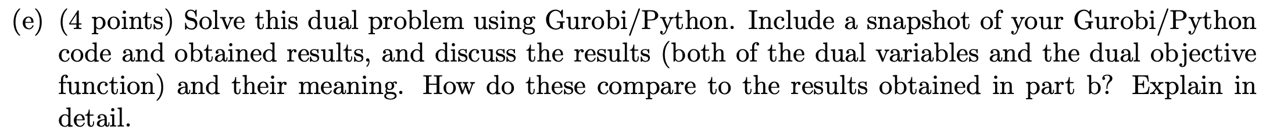
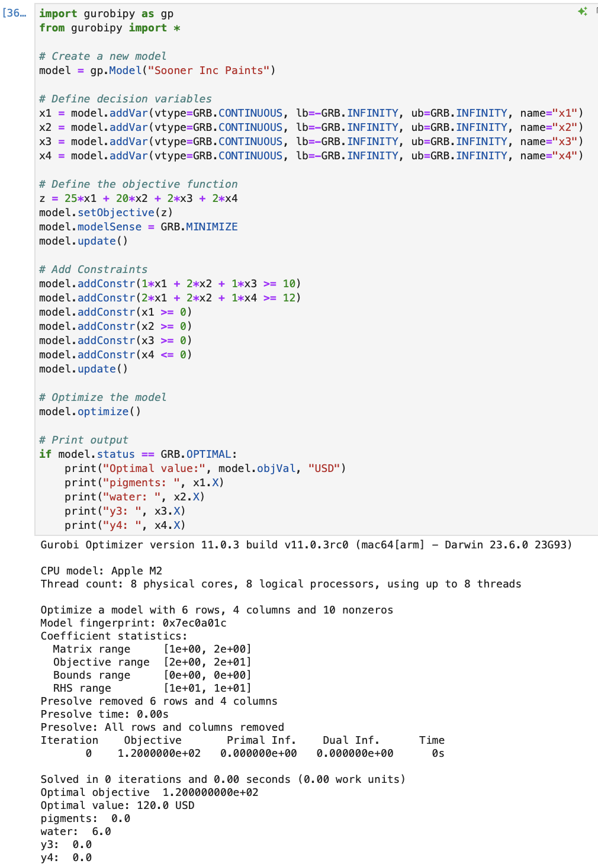
They are the same results found in part b.

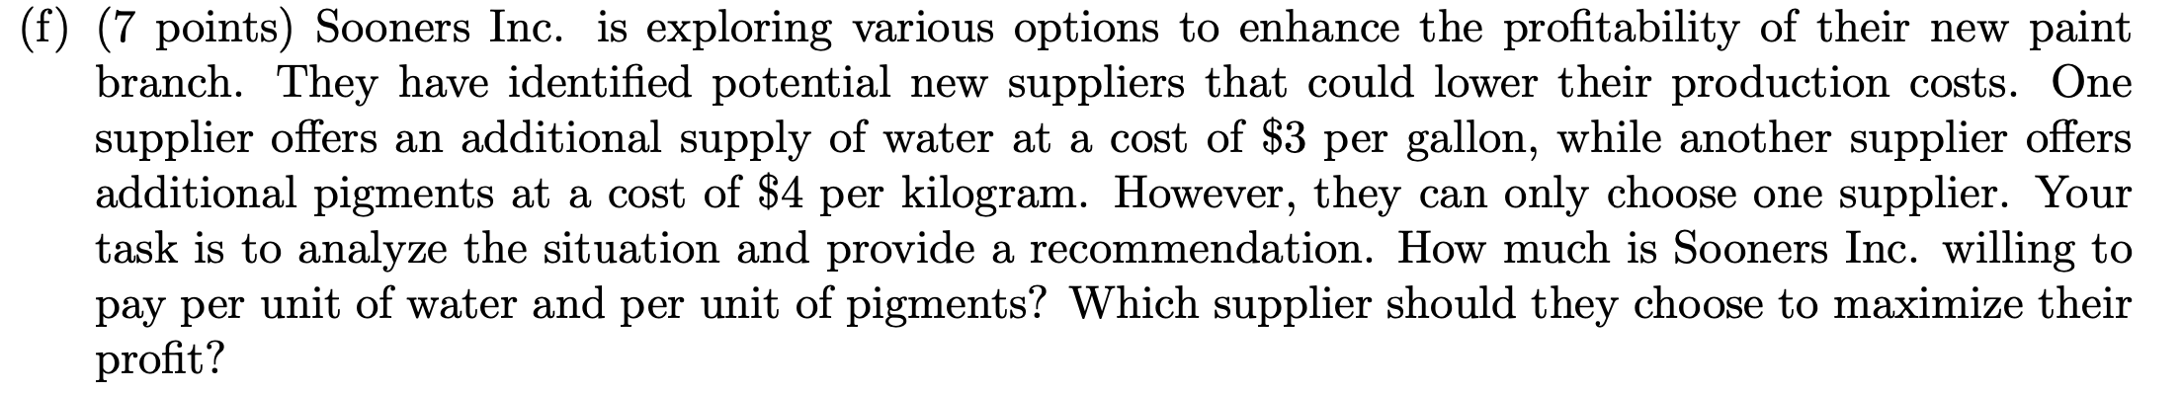

Water: The shadow price for water is $6, which is greater than the supplier’s price of $3 per gallon. This means that purchasing additional water would increase profitability by $3 per gallon ($6 value - $3 cost).
Pigments: The shadow price for pigments is $0, which is less than the supplier’s price of $4 per kilogram. This means that purchasing additional pigments would not increase profitability.
Recommendation:
Sooners Inc. should purchase additional water from the supplier, as it will increase profitability. They should not purchase additional pigments, as there is no benefit in doing so (the shadow price is zero, indicating that the pigment constraint is not binding).

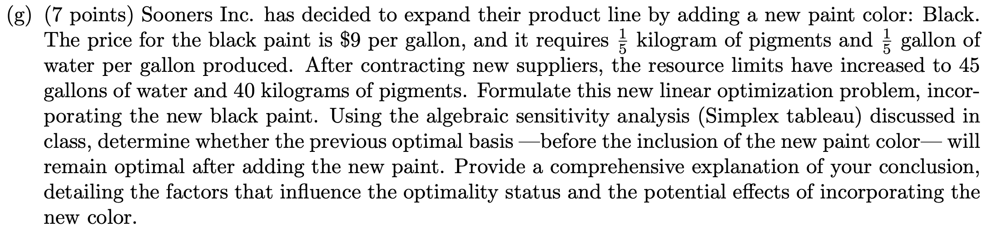

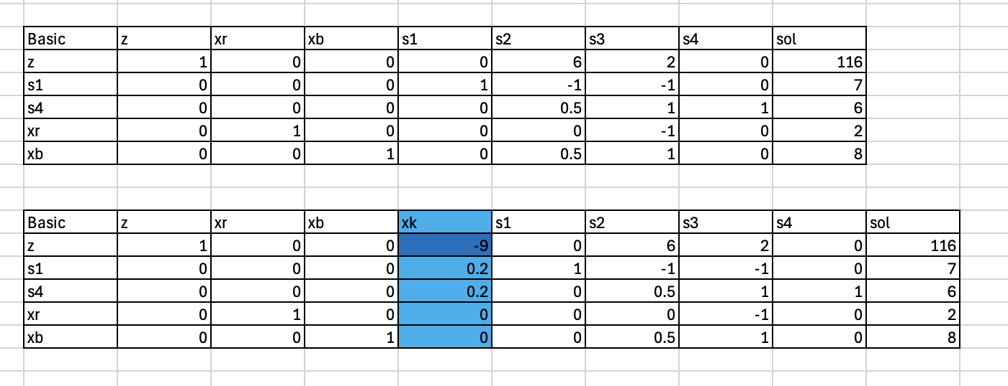
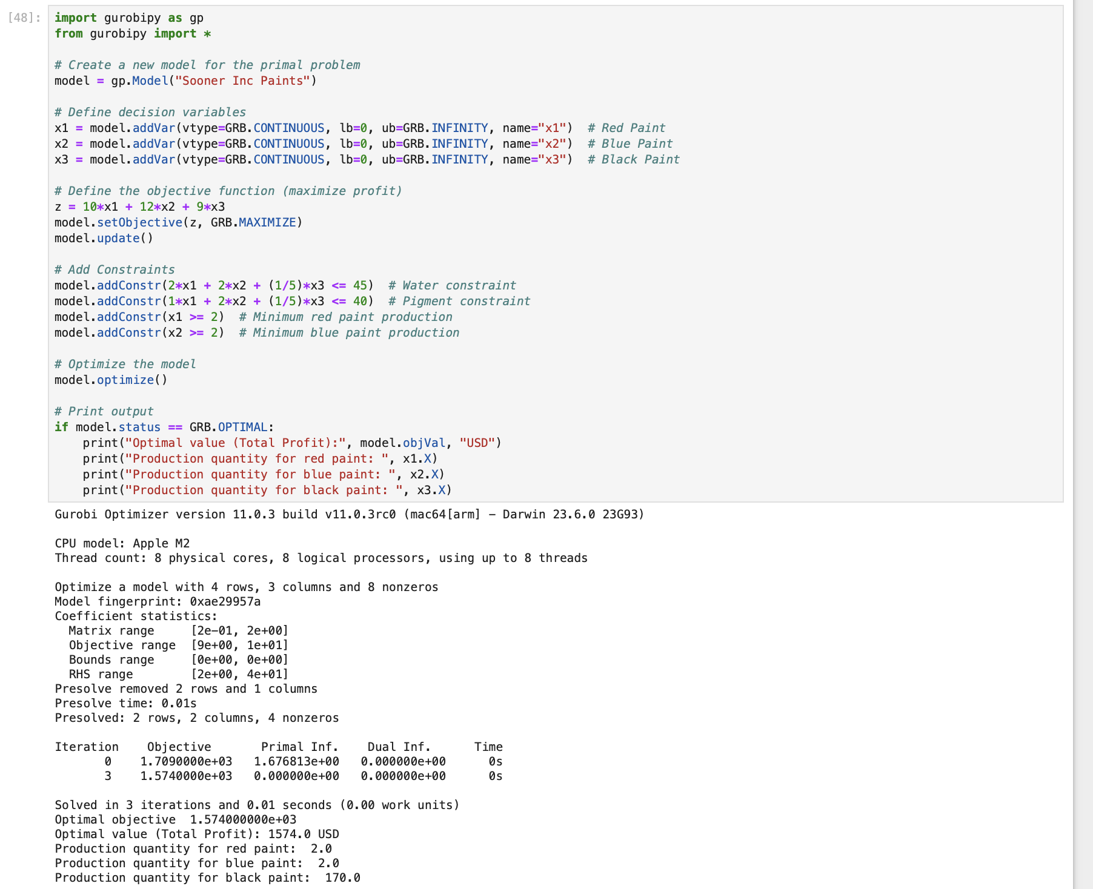

The addition of black paint introduces a new variable that uses fewer resources (water and pigments) per gallon compared to red and blue paints. Since the reduced cost of the black paint variable is negative (-9), black paint will enter the basis, improving the objective function and leading to a new optimal solution, which can be seen in the gurobi result is xr,xb,xk.
